Project Development Phase
Model Performance Test

Team ID | SWTID-2026-7861
Project Name | Auto Ticket Classification using Flow Designer
Maximum Marks

Model Performance Testing:
Project team shall fill the following information in model performance testing template.
S.No. | Parameter | Screenshot / Values
1. | Data Rendered | ServiceNow Incident Workflow ticket form rendered with Caller, Category, Subcategory and Short Description fields.  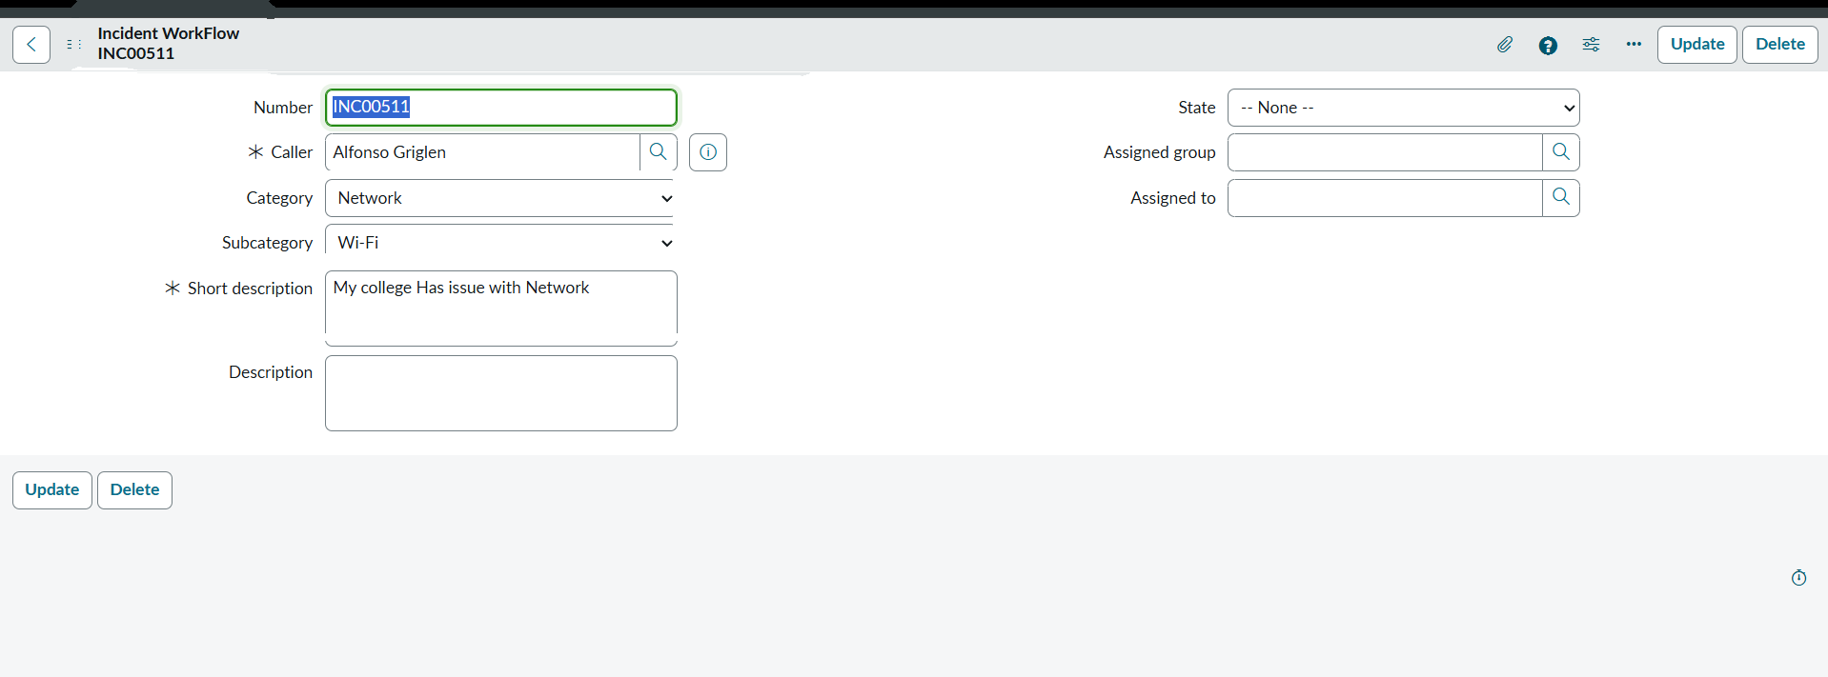
2. | Data Preprocessing | Configured required ticket fields, choice values, and Category–Subcategory dependency for consistent ticket data.  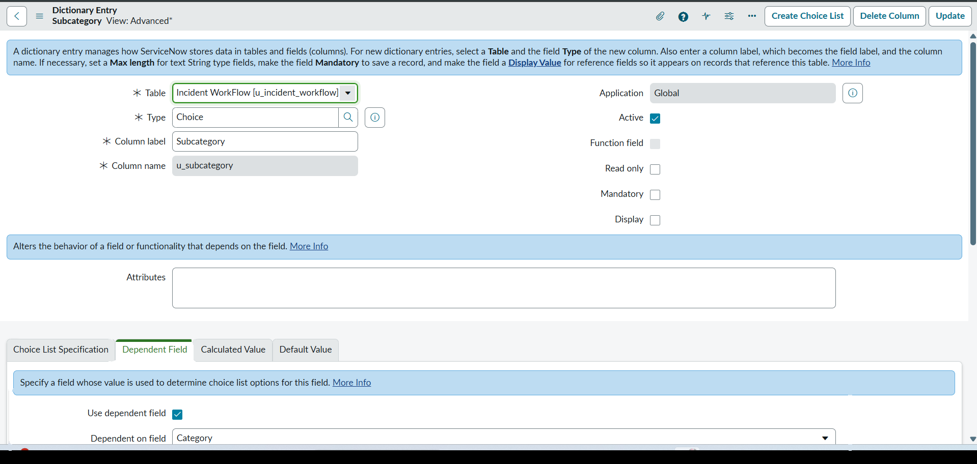
3. | Utilization of Data Filters | Flow conditions filter new records by Category being empty and check keywords such as Wi-Fi, Network, Projector, Password/Login and Slow/Hanging.  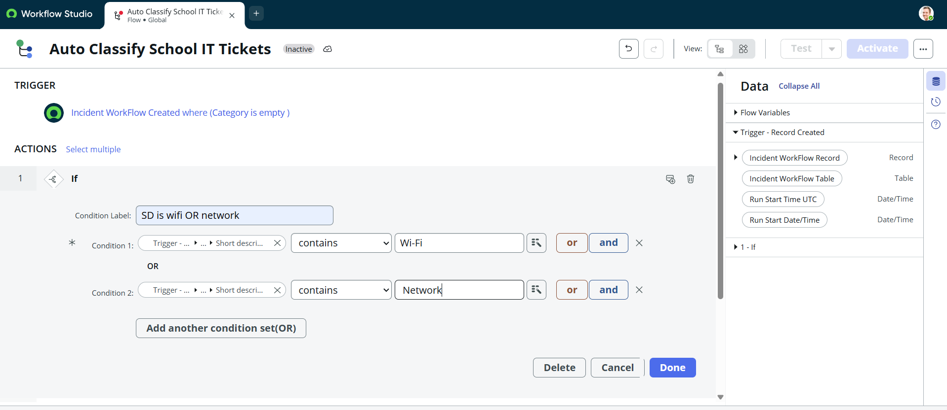
4. | DAX Queries Used | Not Applicable – This project uses ServiceNow Flow Designer automation; no Power BI DAX queries are used.
5. | Dashboard design | Not Applicable – No Power BI dashboard is used. Flow Designer provides the automation workflow for ticket classification.
6. | Report Design | Test output: tickets are automatically assigned the correct Category/Subcategory and a confirmation email is sent to the caller.  